Project Development Phase
Model Performance Test

Date | 19 July 2026
Team ID
Project Name
Maximum Marks

Model Performance Testing:
S.No. | Parameter | Values | Screenshot
1 | Application Summary | SHOPEZ is a MERN Stack E-Commerce application developed using MongoDB, Express.js, React.js, and Node.js. It provides secure user authentication, product browsing, shopping cart management, order processing, and an admin dashboard for managing products and orders. | 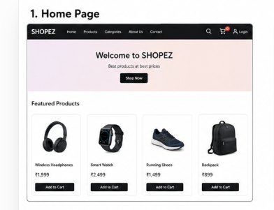
2 | Functional Test Result | Registration, Login, Product Search, Cart Management, Order Placement, and Admin operations were tested successfully. All core functionalities worked as expected. | 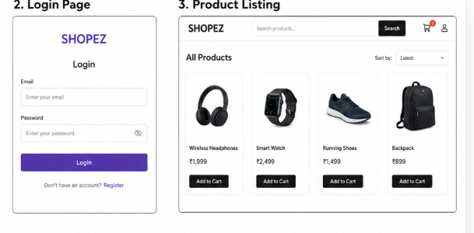
3 | Performance Result | Average page loading time was less than 2 seconds on the local server. API responses were stable during multiple requests, and MongoDB queries executed successfully. | 